Task 1: Connect to your Azure VM and set up your account
1.1 Retrieve your VM Public IP Address [2 marks]

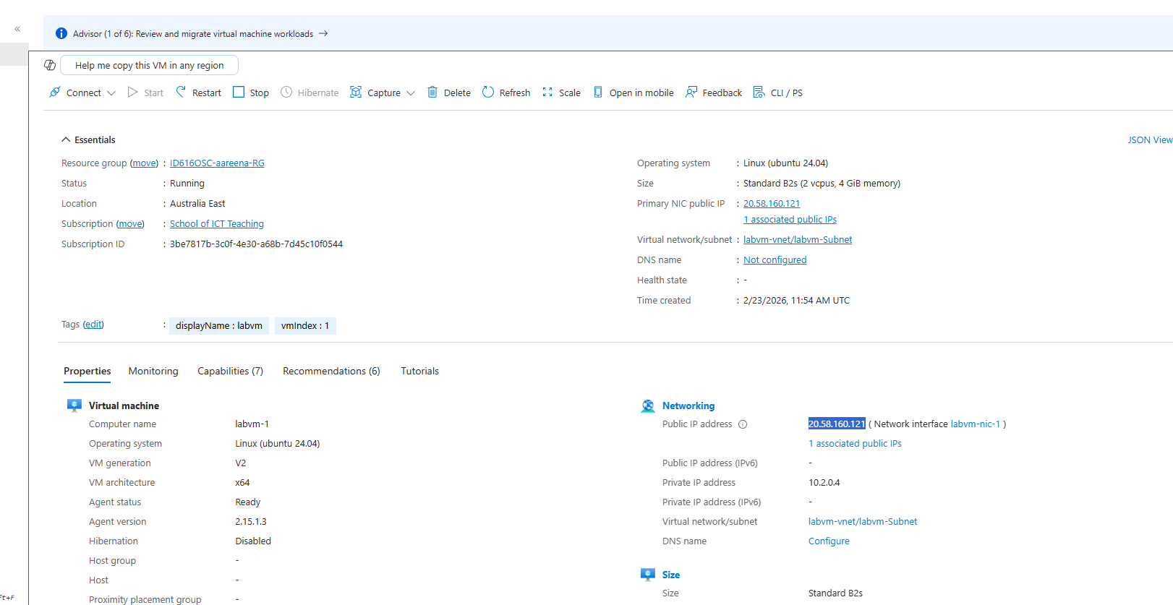
IP Address: 20.58.160.121

1.2: Connect using PuTTY [5 marks]

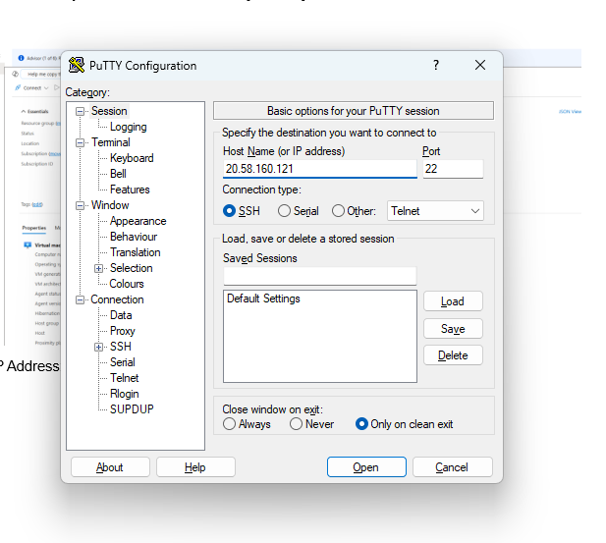

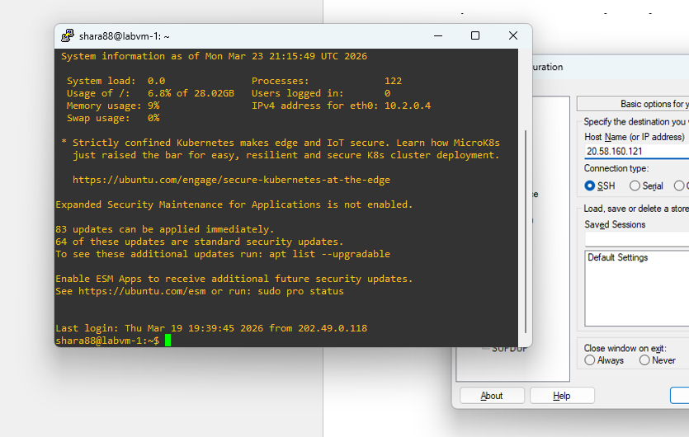

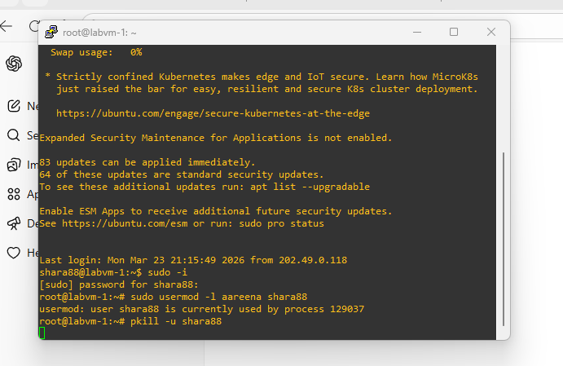

1.3: Change the account username

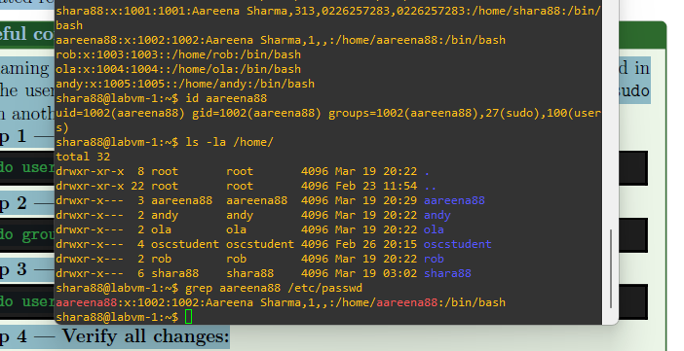
Task 1.4: Change the password

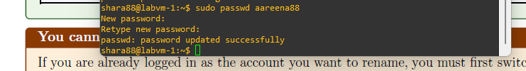

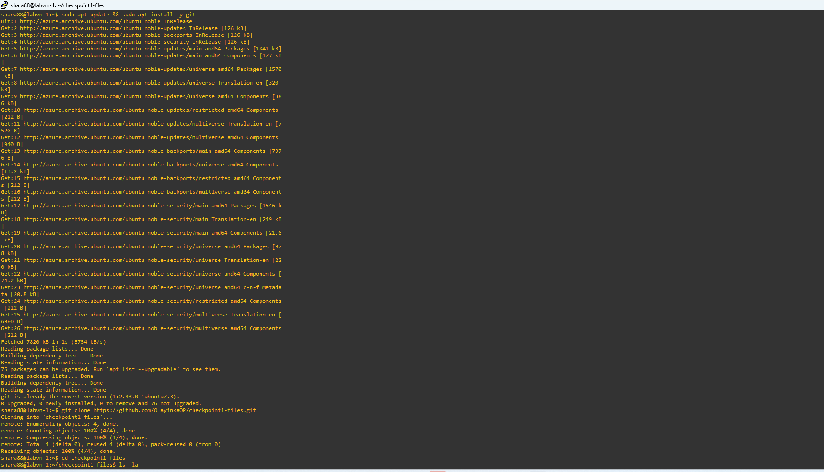
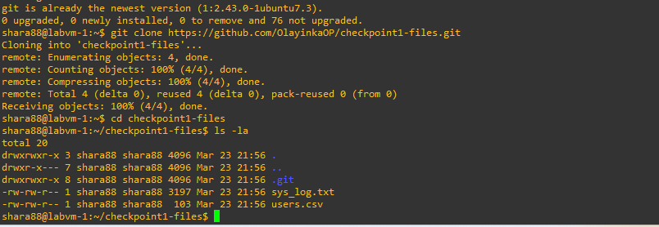

Task 2: Requirement 1: Read and parse users.csv
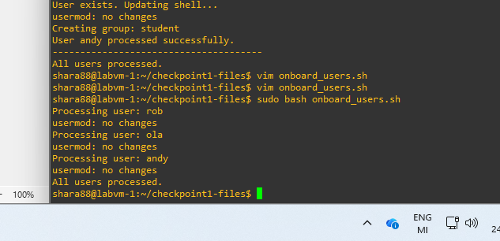
Screenshot: running the script (sudo bash onboard_users.sh) showing output
for multiple users
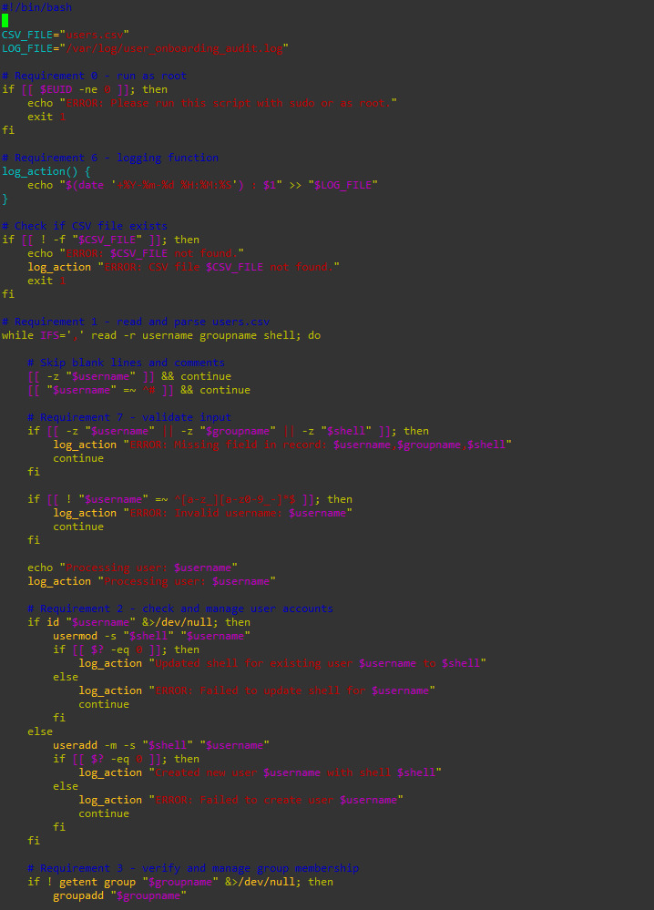
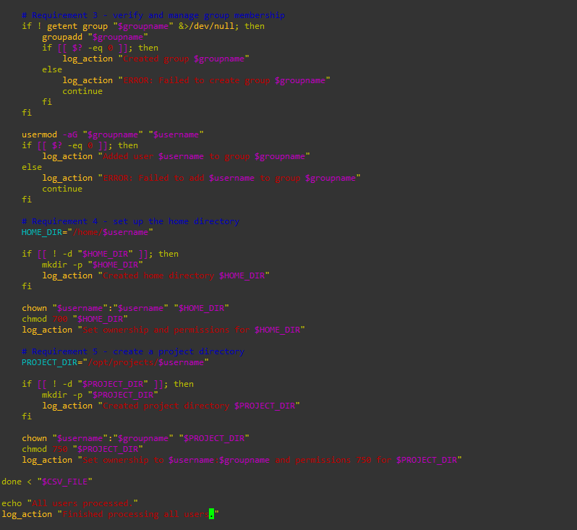
Cap: onboard_users.sh — the complete script with inline comments

Screenshot: contents of /var/log/user_onboarding_audit.log showing timestamped
entries
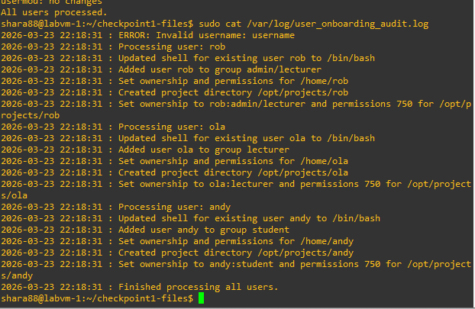
Cap: Audit log showing timestamped entries of user creation, updates, and group management actions.
Screenshot: id <username> and ls -la /home/ /opt/projects/ confirming
at least one user was created correctly
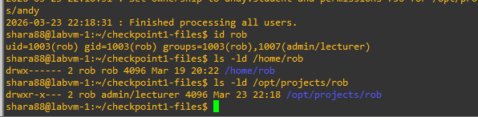
Cap: Verification of user account and directory setup showing correct ownership and permissions for home and project directories.

Screenshot: terminal showing the top 10 token output when the script is run.
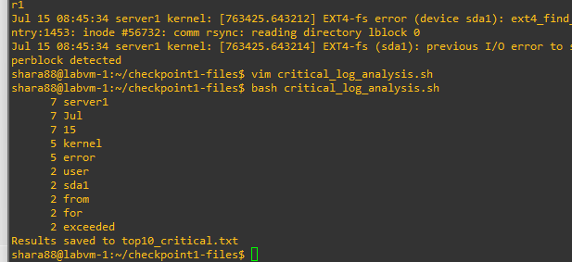

File Submission:
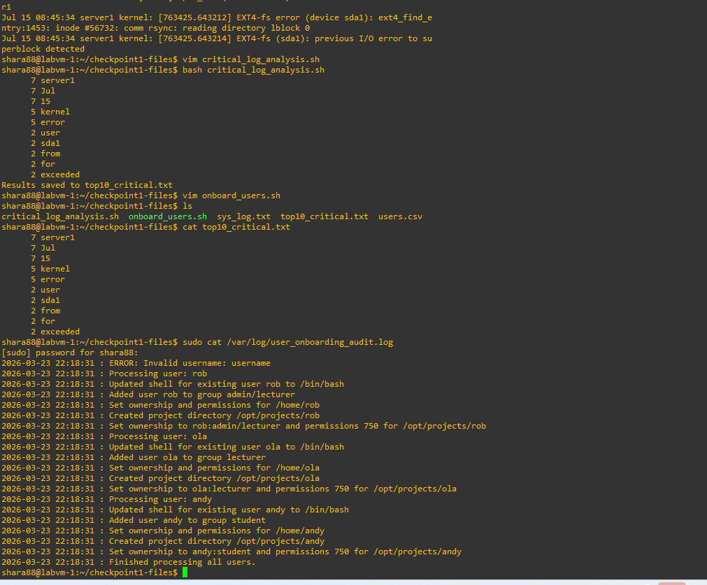
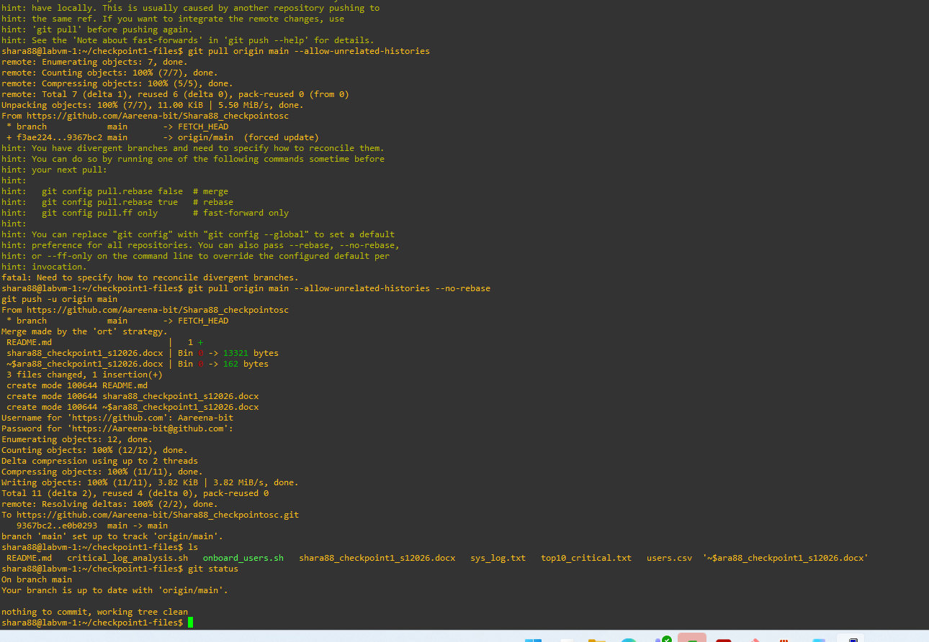
Pushed to git hub
Git hub repo: https://github.com/Aareena-bit/Shara88_checkpointosc.git

